Alice in Sunbury 1964

There are certain years in which the world stands briefly between one thing and another.
1964 was such a year.
The old ways had not fully vanished, and the new ones had not entirely arrived.
Steam trains still breathed beside electric signs. Children still wandered freely beside rivers at dusk. Tea rooms glowed beside modern shopfronts.
For a little while, the world remained undecided enough for Wonderland to find a way back in.

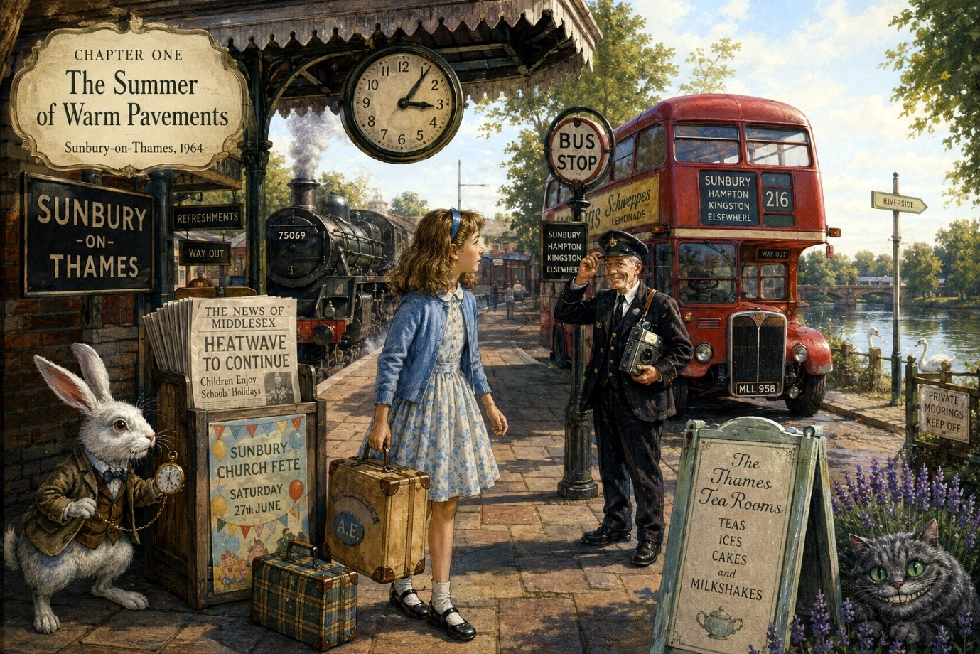
Chapter One

The Summer of Warm Pavements
Nobody remembered precisely when the summer began in Sunbury-on-Thames during 1964, because that particular summer did not arrive properly all at once.
It crept in.
First came the smell of cut grass drifting lazily over garden fences.
Then came the bees.
Then came the long golden evenings where children remained outdoors so late that mothers had to stand at front doors calling names into the dusk like lighthouse keepers guiding ships home through fog.
And finally came the heat.
Not blazing heat. England did not truly approve of blazing heat.
No, this was the sort of heat that softened black tar on roads, made dogs sleep under hedges, and caused bus conductors to loosen their collars while muttering about “absolutely tropical conditions.”
On the morning Alice arrived, the pavements already shimmered gently beneath the sun.
She stood outside Sunbury station beside two large suitcases and one smaller case containing books she fully intended to read and almost certainly would not.
A steam train sighed behind her.
Porters wheeled rattling trolleys along the platform.
Somewhere nearby, a transistor radio played a crackling tune that faded in and out like a voice trying unsuccessfully to remember the words.
Alice adjusted the ribbon in her hair and looked about uncertainly.
The station seemed perfectly ordinary at first glance.
And yet...
Something about it felt wrong.
Not frighteningly wrong.
Only slightly sideways.
The station clock, for example, ticked far too loudly.
TICK.
TICK.
TICK.
As though determined everybody should notice time passing.
An elderly woman feeding pigeons appeared to be arguing with her handbag.
And a boy sitting on a luggage trolley was attempting to teach a goldfish how to whistle.
Nobody else seemed remotely concerned.
Alice narrowed her eyes.
“I do believe,” she murmured quietly, “that strange things are already happening.”
“Of course they are.”
Alice turned sharply.
The speaker was a bus conductor standing beside the station entrance.
He was a small man with silver buttons upon his uniform and a remarkably long nose. He held a ticket machine against his chest like a musical instrument.
Most curious of all, he tipped his hat politely and said:
“Welcome back, Miss Alice.”
Alice blinked.
“I beg your pardon?”
“Terribly sorry,” said the conductor quickly. “Thought you were somebody else.”
“But you said my name.”
“Did I?”
“Yes.”
“How peculiar.”
The conductor frowned thoughtfully at his ticket machine as though it might explain matters.
Then he smiled.
“Well then. Best be careful near the river after six o’clock.”
“Why?”
But the conductor had already climbed aboard a waiting red bus.
A moment later it rattled away down the road with a hiss of smoke and sunlight flashing from its windows.
Alice stared after it.
On the rear of the bus, written very neatly in white paint, were the words:
SUNBURY - HAMPTON - KINGSTON - ELSEWHERE
Alice frowned.
Elsewhere?
Surely buses were not supposed to go elsewhere.
A voice suddenly boomed behind her.
“ALICE!”
She jumped.
Charging toward her across the station forecourt came Aunt Edith, wearing enormous sunglasses and carrying enough shopping bags to suggest she had recently survived a minor disaster in a department store.
“Aunt Edith!”
“Well honestly,” puffed Aunt Edith, embracing her warmly. “You’ve grown at least six inches since Christmas.”
“I don’t think I have.”
“No, perhaps not. Still, one never knows with girls your age. Come along quickly. Your uncle’s parked illegally again.”
She lowered her voice.
“Your Uncle Harold believes yellow lines are merely suggestions.”
“That sounds dangerous.”
“It is. Last Thursday he parked beside a policeman and offered him a peppermint.”
They crossed the forecourt together toward a pale green Morris Minor baking gently in the sunshine.
Alice paused suddenly.
There, beside the station wall, half-hidden behind a newspaper stand, stood a white rabbit.
Not an ordinary rabbit.
This rabbit wore a tiny brown waistcoat.
And held a pocket watch.
Alice stared.
The rabbit glanced up nervously.
For one terrible and wonderful moment, their eyes met.
Then the rabbit vanished behind the newspaper stand.
Alice hurried forward.
But when she looked behind it, there was nothing there except newspapers fluttering softly in the warm wind.
“Alice?” called Aunt Edith. “What are you doing?”
“Nothing,” said Alice slowly.
But as she turned back toward the car, she noticed something else.
The station clock had stopped.
Not broken.
Stopped.
Frozen at exactly six minutes past three.
And although every sound around her continued normally, Alice could not shake the peculiar feeling that somewhere nearby...
something had just woken up.

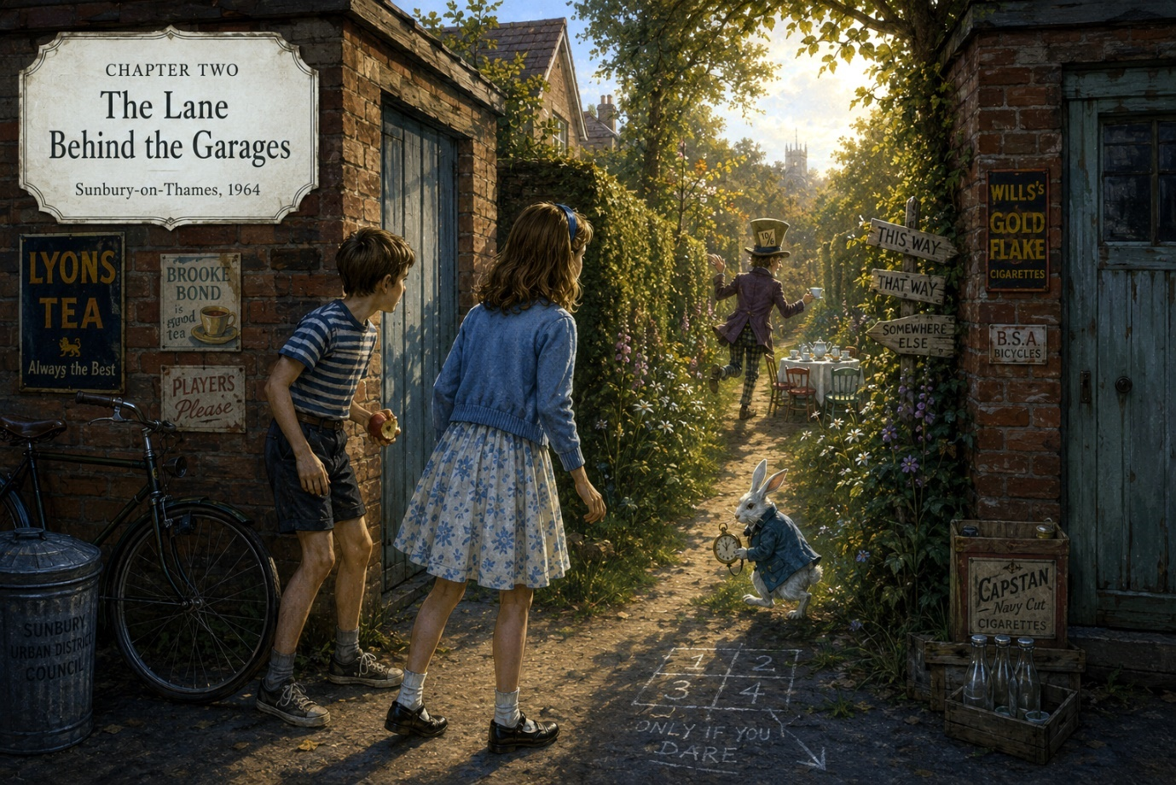

Chapter Two

The Lane Behind the Garages
Uncle Harold’s house stood upon a quiet road lined with rose bushes, polished bicycles, and identical hedges that seemed to have signed some sort of agreement to remain exactly the same height forever.
The garden gate squeaked importantly when opened.
The front path smelled faintly of warm stone and lavender.
And somewhere nearby, hidden beyond rows of houses and allotments, the River Thames moved slowly beneath the summer sun like a great brown-green snake pretending to be harmless.
“It’s smaller than I remembered,” said Alice as Aunt Edith unlocked the front door.
“That is because you are bigger,” replied Aunt Edith wisely.
Inside, the house was pleasantly cool.
A clock ticked upon the mantelpiece.
The wireless murmured quietly in the sitting room.
And the entire place smelled faintly of furniture polish, tea leaves, and something baking.
“Cherry sponge,” announced Aunt Edith proudly. “Though your Uncle Harold says it could also be used to repair potholes.”
“I’m sure it’s lovely.”
“It is not supposed to bounce, Alice.”
From somewhere upstairs came a loud crash followed by Uncle Harold shouting:
“FOUND IT!”
Aunt Edith sighed deeply.
“He’s looking for the spare lightbulbs.”
“What crashed?”
“The wardrobe, I think.”
A second crash followed.
“Definitely the wardrobe.”
Alice smiled faintly.
Already the strange feeling from the station had not vanished.
If anything, it had grown stronger.
The house itself felt ordinary enough, yet now and then she noticed peculiar little things:
- a teaspoon bending slightly when nobody touched it
- a framed painting whose clouds appeared to move
- a hallway clock running two minutes backwards
- a soft distant laughter that seemed to drift through the walls whenever no one spoke
Most curious of all was the wallpaper in the upstairs spare bedroom.
Tiny rabbits decorated it.
Hundreds of them.
Each wore little blue coats.
And one of them, near the wardrobe, appeared to be carrying a pocket watch.
Alice stepped closer.
The rabbit seemed perfectly normal now.
She frowned.
Then something tapped gently against the window.
Alice turned.
Outside, beyond the garden fence, a boy about her age sat perched upon the wall eating an apple.
He wore a striped shirt, scuffed shoes, and an expression suggesting he spent most of his life discovering things adults preferred remained undiscovered.
“You’re the new girl,” he announced.
“I’m not new exactly.”
“You arrived today.”
“That’s true.”
The boy nodded as though this confirmed an important scientific theory.
“I’m Peter.”
“Alice.”
His expression changed instantly.
“Oh.”
“Oh what?”
“You really are Alice.”
“That is generally how names work.”
Peter climbed down from the wall.
“You’d better come with me.”
“Why?”
“Because it’s started again.”
Alice narrowed her eyes suspiciously.
“What’s started again?”
But Peter was already hurrying down the lane beside the house.
After only the briefest hesitation, Alice followed.
The afternoon sun glowed golden upon garages, fences, washing lines, and rows of carefully tended gardens. Somewhere a lawnmower buzzed angrily.
Peter led her through narrow side streets until they reached a row of brick garages standing behind the houses like quiet red sentries.
“There,” he whispered.
“At what?”
“The lane.”
“There isn’t a lane.”
“There is after half past four.”
Alice glanced at her watch.
4:28.
Peter folded his arms confidently.
“It never appears early.”
“That’s ridiculous.”
“Probably.”
The air suddenly shifted.
Not dramatically.
Only enough to make the hairs upon Alice’s arms rise slightly.
The sunlight dimmed for one peculiar moment, although no cloud crossed the sky.
Then, very slowly...
something appeared between two garages.
At first it looked merely like shadow.
Then like mist.
Then like a narrow winding lane that absolutely had not been there before.
Alice stared.
The lane curved away between tall hedges she did not recognise. Strange flowers nodded lazily in the warm breeze.
And somewhere far along its hidden length came the unmistakable sound of teacups clinking together.
Peter swallowed nervously.
“It’s farther away this time.”
“What is?”
“The tea party.”
Alice looked at him sharply.
“You know about the tea party?”
“Everybody knows about it.”
“Everybody?”
“Well... everybody who notices things.”
Before Alice could reply, movement flickered deep within the lane.
A tall figure crossed briefly between the hedges.
A man wearing a hat far too large for his head.
Then he vanished again.
Alice’s heart began beating faster.
The air smelled suddenly of river water, peppermint, old books, and summer rain.
And drifting faintly toward them through the impossible lane came a voice singing softly:
“Twinkle, twinkle, little bat...”
Peter stepped backward immediately.
“Oh no.”
“What?”
“He’s awake.”
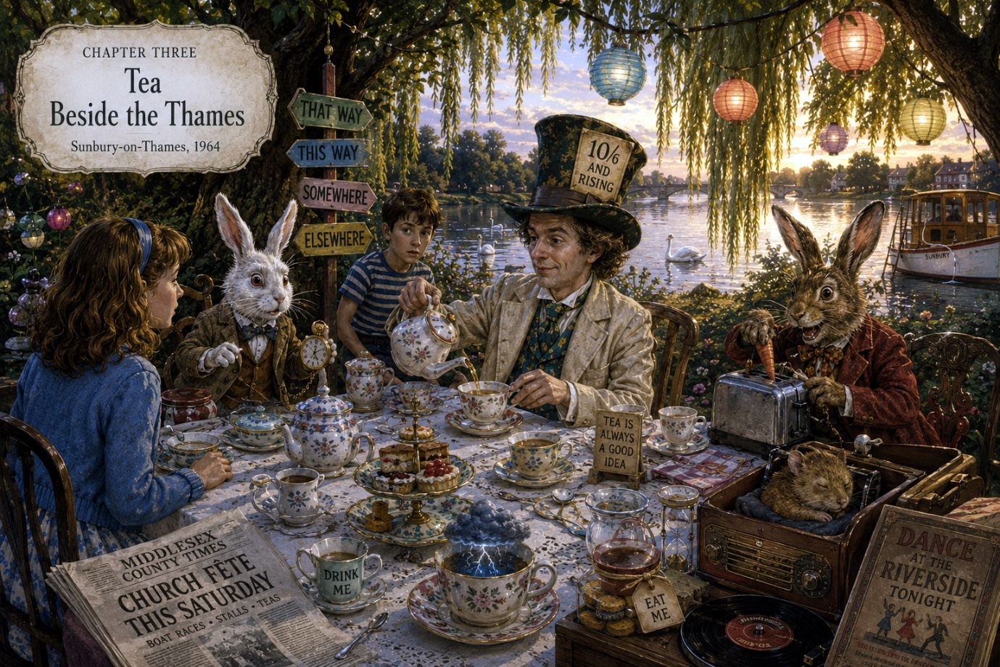

Chapter Three

Tea Beside the Thames
Peter retreated so quickly he nearly collided with a dustbin.
“We should go,” he whispered urgently.
“Why?”
“Because last time he asked my cousin Dennis what day it was.”
“That doesn’t sound terribly dangerous.”
“It took Dennis three weeks to answer.”
Alice looked back toward the impossible lane.
The sunlight inside it had changed.
Only moments ago it had resembled an ordinary summer afternoon. Now it glowed amber and gold like the inside of an old lantern.
The distant clinking of teacups continued.
Then came laughter.
Not unpleasant laughter.
But the sort of laughter belonging to people who understood jokes nobody else had heard yet.
Alice took one careful step forward.
The air instantly cooled around her.
Behind her, the ordinary world of garages and bicycles and washing lines seemed suddenly very far away.
Peter grabbed her sleeve.
“You mustn’t go too far.”
“Why not?”
“Because sometimes it forgets to bring people back properly.”
“That is an alarming sentence.”
“I know.”
Alice hesitated.
Then somewhere farther along the lane came a familiar flustered voice:
“Oh dear. Oh dear. Positively catastrophic.”
The White Rabbit hurried into view.
He looked exactly as Alice remembered and yet not entirely the same.
His whiskers were greyer now.
His waistcoat slightly faded.
And attached to his pocket watch by string was a tiny pencil and several folded bus tickets.
He stopped abruptly upon seeing Alice.
For one long moment, neither spoke.
Then the Rabbit removed his spectacles slowly.
“Well,” he breathed softly.
“You know me,” said Alice.
“My dear child, I once spent three weeks searching for your left shoe.”
“I only lost it for an afternoon.”
“Yes,” sighed the Rabbit. “A devastating afternoon.”
Peter made a strangled noise of panic.
“You know the rabbit?”
The Rabbit glanced at Peter suspiciously.
“Who’s this?”
“Peter.”
“Does he ask questions?”
“Frequently.”
“How unfortunate.”
The Rabbit checked his watch.
Then checked the sky.
Then checked a nearby sunflower.
The sunflower nodded reassuringly.
“Good,” muttered the Rabbit. “Still Thursday.”
Alice blinked.
“Do flowers normally know what day it is?”
“In difficult areas, yes.”
Farther down the lane, music drifted through the hedges.
A gramophone played something scratchy and cheerful.
The Rabbit twitched nervously.
“We really oughtn’t linger. He’s in one of his conversational moods today.”
“The Hatter?”
“Worse.”
“Worse than the Hatter?”
“The Hatter with opinions about modern plumbing.”
Peter stepped backward again.
“I’m definitely not coming.”
“Suit yourself,” said Alice.
“You’ll disappear.”
“I might.”
“You sound oddly calm about that.”
Alice looked down the winding lane where impossible sunlight danced between the hedges.
Then she smiled slightly.
“To be honest,” she said, “it already feels rather as though I’ve been here before.”
And with that, she stepped fully into the lane.
The world shifted immediately.
Not violently.
More like a page turning.
The ordinary sounds of suburban Sunbury faded softly away until all Alice could hear was birdsong, river water, gramophone music, and distant conversation.
The lane widened gradually.
Wildflowers grew everywhere:
- foxgloves
- daisies
- bluebells entirely out of season
- roses climbing impossible distances
And hanging from branches overhead were dozens of teacups gently swaying in the breeze.
Each cup contained something different.
Rainwater.
Buttons.
Clock springs.
One appeared to contain a tiny thunderstorm.
The White Rabbit hurried ahead anxiously.
“We’ve had terrible trouble since electricity arrived.”
“What sort of trouble?”
“The wrong sort.”
“That is not very specific.”
“Neither is electricity.”
Ahead, the hedges finally opened.
Alice stopped dead.
The tea party stretched along the riverside beneath enormous willow trees beside the Thames itself.
Except this was not quite the Thames she knew.
The river here shimmered strangely silver beneath the evening light, reflecting clouds that did not exist overhead.
Long tables stood beneath coloured lanterns.
Dozens of mismatched chairs surrounded them.
Steam rose from kettles.
Gramophones played cheerful dance music from the 1920s and, occasionally, music that had not been invented yet.
The March Hare was attempting to repair a toaster with a carrot.
The Dormouse slept peacefully inside a wireless radio.
And at the very centre of it all sat the Mad Hatter.
He wore a cream-coloured suit slightly too large for him, a green tie covered in tiny teapots, and a hat bearing a price label that now read:
10/6 AND RISING
The Hatter looked up slowly as Alice approached.
For once, he did not grin wildly.
Instead, he smiled with genuine warmth.
“Well,” he said quietly, “there you are at last.”
Alice suddenly felt something very peculiar.
Not fear.
Not surprise.
Something closer to homesickness for a place she had not realised she missed.
The Hatter poured tea carefully into a china cup.
“We kept your seat ready,” he said.

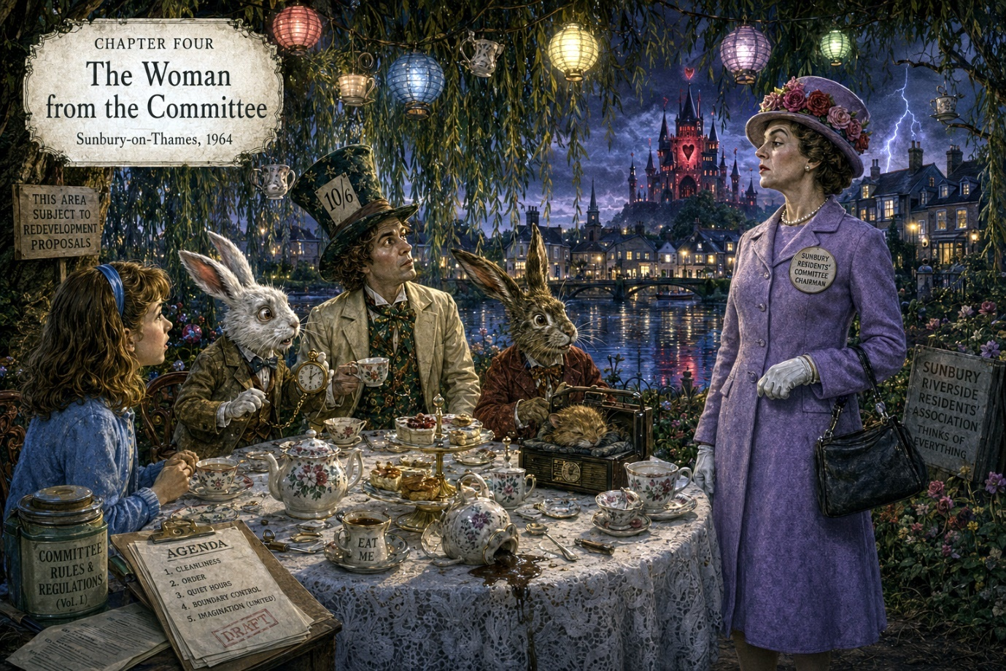

Chapter Four

The Woman from the Committee
The tea tasted faintly of blackberries, thunderstorms, and memories Alice could not quite place.
“That’s unusual,” she remarked after her first sip.
The Hatter looked pleased.
“It was originally raspberry, but the kettle became emotional.”
“That happens to kettles here?”
“Oh yes,” said the March Hare. “Particularly near the river.”
He was now dismantling the toaster with a butter knife while muttering darkly about “electrical conspiracies.”
The Dormouse snored gently inside the wireless.
Every few moments the radio crackled and produced fragments of dreams instead of programmes.
“…and now the weather for next Tuesday…”
“…too much marmalade in Parliament…”
“…beware the woman in lavender…”
The White Rabbit shuddered visibly.
“Must we mention her?”
The Hatter’s cheerful expression faded slightly.
“I suppose,” he said carefully, “that eventually we must.”
Alice noticed at once that the atmosphere around the table had changed.
Even the lanterns dimmed a little.
The silver Thames beside them rippled softly beneath the evening sky. Far away across the water stood ordinary Sunbury:
- church spires
- chimney pots
- glowing windows
- distant traffic
- bicycles crossing bridges
And yet none of it looked entirely real from here.
It resembled a reflection.
The true world, Alice suspected suddenly, might actually be this one.
The Hatter folded his hands.
“You must understand something, Alice. Wonderland did not vanish.”
“It didn’t?”
“No. It simply became... difficult.”
“That sounds like taxes,” muttered the March Hare.
“Everything sounds like taxes to you.”
“Because they’re everywhere.”
The Rabbit climbed nervously onto a chair.
“The trouble began after the war. Then came televisions, motorways, office buildings, parking regulations…”
“And committees,” said the Hatter darkly.
At the very mention of the word, a cold wind drifted across the tea table.
The gramophone needle screeched.
Somewhere overhead, the hanging teacups began trembling softly.
Alice frowned.
“What sort of committees?”
The White Rabbit lowered his voice dramatically.
“Residents’ associations.”
The river itself seemed to shiver.
Then, from somewhere farther down the riverside path, came the sharp sound of footsteps.
Measured.
Precise.
Approaching.
The March Hare immediately hid behind the toaster.
The Rabbit dived beneath the tablecloth.
Even the Dormouse briefly woke, squeaked in terror, and vanished into the radio again.
Only the Hatter remained seated.
Though now Alice noticed he was gripping his teacup rather tightly.
The footsteps stopped.
A woman stood beneath the willow trees.
She wore a lavender coat despite the summer heat, white gloves, and a hat decorated with roses so red they looked freshly painted.
Everything about her appeared perfectly respectable.
Which somehow made her much more alarming.
She smiled pleasantly.
“Good evening.”
Nobody answered.
The woman’s eyes settled upon Alice.
“Well,” she said softly. “So she’s returned.”
Alice felt a strange chill run through her.
“I don’t think we’ve met.”
“No,” said the woman. “Not properly.”
The Hatter rose slowly.
“You are not welcome here, Mrs Redgrave.”
Mrs Redgrave.
The name sounded ordinary.
Far too ordinary.
That, Alice suspected, was intentional.
Mrs Redgrave glanced disapprovingly around the tea table.
“This entire area remains in violation of several local regulations.”
“Wonderful,” sighed the Hatter. “She’s brought regulations.”
“You cannot simply continue existing wherever you please.”
“We’ve done remarkably well so far.”
“This riverside falls under redevelopment proposals.”
The March Hare poked his head cautiously from behind the toaster.
“You can’t redevelop a tea party.”
Mrs Redgrave smiled thinly.
“One can redevelop anything.”
At that exact moment, somewhere behind the willow trees, thunder rolled softly across the sky.
Except the sky above them remained perfectly clear.
Alice looked upward.
Far across the silver Thames, dark clouds had begun gathering over ordinary Sunbury.
Streetlights flickered alive too early.
Windows glowed amber in the deepening evening.
And for one brief instant, Alice saw something impossible reflected upon the water:
A vast palace of red and black towers rising behind the suburban streets.
Then the reflection vanished.
Mrs Redgrave stepped closer.
“The boundary is weakening again,” she said quietly. “Which means decisions must be made.”
The White Rabbit emerged trembling from beneath the table.
“She wants to close the crossings.”
“Of course I do,” replied Mrs Redgrave. “Wonderland is untidy. Expensive. Entirely impractical.”
The Hatter’s voice sharpened.
“It is alive.”
“It is outdated.”
“It is necessary.”
“It is inconvenient.”
The lanterns overhead flickered wildly.
The river swirled.
And Alice suddenly realised something terrible.
This was not merely an argument.
It was a war.
Not fought with armies.
But with memory.
Wonder against order.
Imagination against neatness.
And somewhere in the gathering darkness beyond the riverside willows, Wonderland itself seemed to be listening.

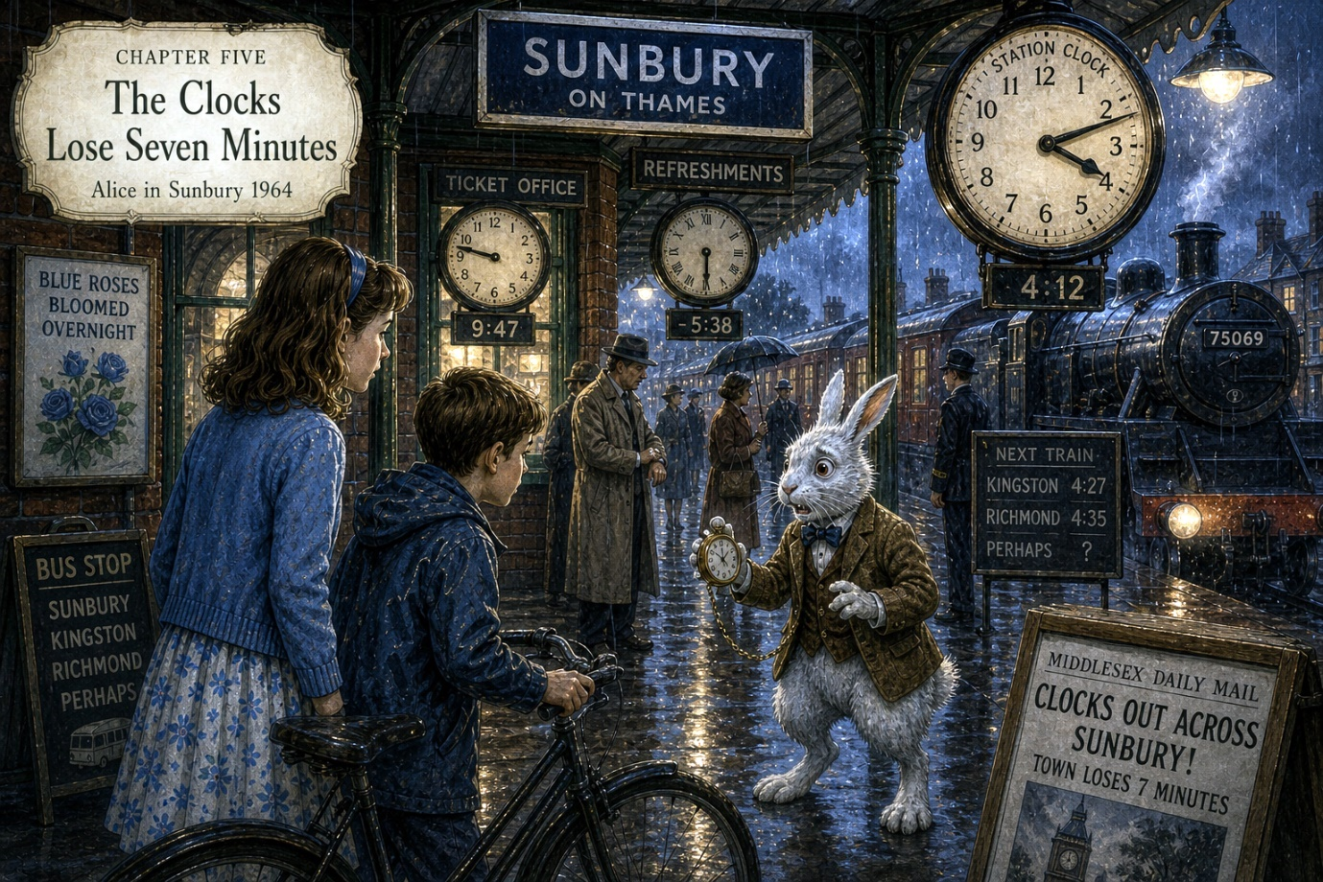

Chapter Five

The Clocks Lose Seven Minutes
That night, ordinary Sunbury-on-Thames began behaving strangely.
Not dramatically at first.
The town did not split apart.
No dragons flew above the rooftops.
Nobody turned into a teapot during supper.
Instead, peculiar little errors began appearing quietly around the edges of things.
Mr Wheeler, who delivered milk at half past five every morning without fail, arrived before he had actually left home.
A woman on Green Street heard tomorrow’s weather forecast on tonight’s wireless.
Three boys fishing near the river watched the sun set twice.
And every clock in Sunbury lost exactly seven minutes.
Not six.
Not eight.
Seven.
Nobody could explain where the missing minutes had gone.
At breakfast, Aunt Edith noticed first.
“This clock’s wrong.”
Uncle Harold glanced up from his newspaper.
“So’s the radio.”
“So’s your wristwatch.”
“That’s impossible,” said Uncle Harold. “It was perfectly accurate in 1958.”
The kitchen clock ticked loudly.
Too loudly.
Alice stared at it over her toast.
Tick.
Tick.
Tick.
The second hand appeared hesitant now, as though uncertain whether time itself still wished to continue.
Outside, rain clouds drifted low above the rooftops despite yesterday’s heat.
The world smelled different too.
Cooler.
Sharper.
As though the air before a thunderstorm had somehow become trapped inside the entire town.
Aunt Edith poured tea.
“Honestly,” she muttered, “Sunbury feels peculiar today.”
Alice nearly dropped her spoon.
“You feel it too?”
“Feel what?”
“That something’s changed.”
Aunt Edith paused.
Then, very quietly, she said:
“Well... the roses bloomed overnight.”
“What’s strange about that?”
“They bloomed blue.”
Uncle Harold lowered his newspaper immediately.
“Nobody mentions the blue roses.”
“Harold.”
“I mean it, Edith. Last time we mentioned unusual gardening, the begonias sang for six weeks.”
Alice stared.
“You know about strange things?”
Both adults froze.
Then Uncle Harold coughed awkwardly and reopened his newspaper upside down.
“Absolute nonsense,” he declared.
A teacup slid slowly three inches across the table entirely by itself.
Nobody commented.
Outside, a bus rumbled past the house.
Alice hurried to the window.
The destination board read:
SUNBURY - KINGSTON - RICHMOND - PERHAPS
She turned back slowly.
“Aunt Edith...”
But Aunt Edith was already pulling the curtains closed.
“You are not to wander near the river after dark.”
“Why?”
“Because it isn’t staying where it should.”
That afternoon the rain finally arrived.
Warm summer rain.
The sort that turns roads silver and fills gutters with dancing reflections.
Alice sat upstairs beside the bedroom window watching drops slide down the glass while distant thunder rolled somewhere over the Thames.
The rabbit wallpaper appeared restless today.
Several rabbits seemed to have moved position slightly.
One now carried an umbrella.
Another appeared to be running.
Then, very softly, came tapping at the window.
Peter stood outside balancing dangerously upon the garden wall beneath the rain.
“You need to come quickly.”
Alice opened the window.
“What’s happened?”
“The station.”
“The station what?”
“The clocks are arguing.”
“That sentence makes no sense.”
“I know. Hurry.”
Ten minutes later they were cycling through rainy streets beneath flickering lamps and dripping trees.
The whole town felt wrong now.
People glanced nervously at watches.
Shopkeepers reset clocks repeatedly.
A policeman stood in the middle of the road staring suspiciously at the church tower.
And everywhere Alice looked she noticed tiny impossible things:
- puddles reflecting sunny skies despite the rain
- newspaper headlines changing when unread
- cats staring knowingly from windows
- footsteps occasionally continuing after people stopped walking
When they reached the station, Alice stopped dead.
Every clock showed a different time.
The great station clock read 4:12.
The ticket office clock read 9:47.
A small clock above the platform café spun slowly backwards.
Passengers stood about muttering anxiously.
Steam drifted through the damp evening air.
And standing alone beneath the station canopy was the White Rabbit.
He looked utterly horrified.
“It’s worse than I thought,” he whispered as Alice approached.
“What’s happening?”
The Rabbit swallowed hard.
“The missing seven minutes.”
“What about them?”
He looked around nervously before lowering his voice.
“They’ve turned up somewhere else.”

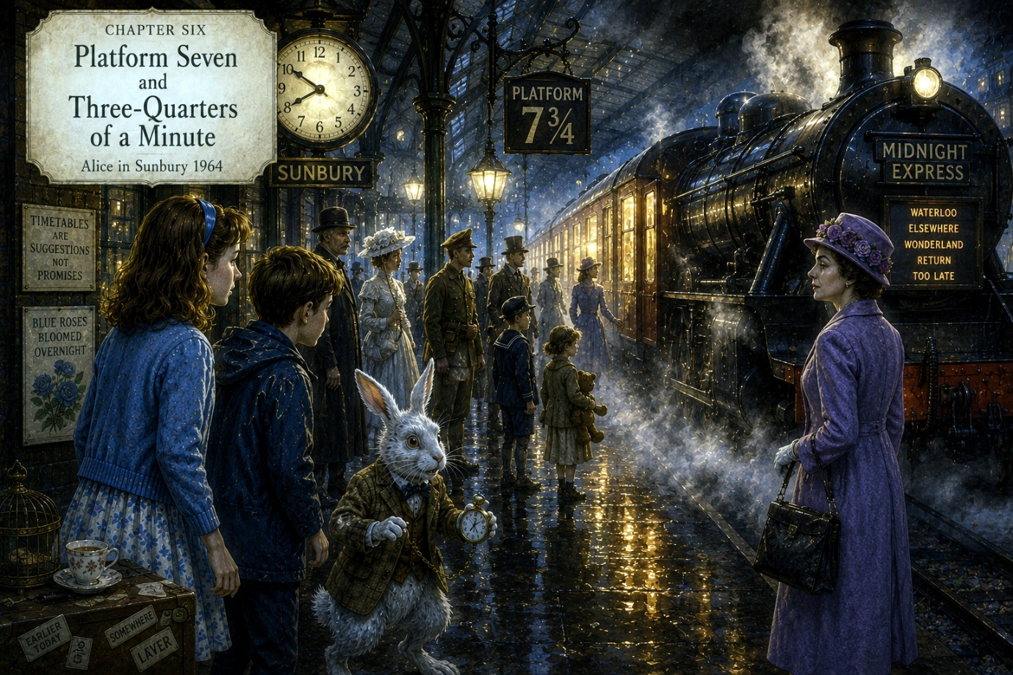

Chapter Six

Platform Seven and Three-Quarters of a Minute
Rain whispered against the station roof.
Steam drifted through the lamps in pale white clouds.
And all around Sunbury-on-Thames, time itself appeared to be losing confidence.
The White Rabbit paced anxiously beneath the station clock.
“They should never have been left unattended.”
“The seven minutes?” asked Alice.
“Yes.”
Peter frowned.
“You’re talking as though minutes are actual objects.”
“They are,” snapped the Rabbit. “Particularly important minutes.”
“That doesn’t explain anything.”
“Very little does.”
A porter hurried past carrying three suitcases and a goldfish bowl full of daffodils.
Nobody seemed entirely certain where they were supposed to be going.
The station loudspeaker crackled overhead.
“The train now arriving at Platform Two is the 5:14 service to Richmond, Kingston, and yesterday afternoon.”
Passengers glanced upward nervously.
A businessman checked his watch and sighed.
“Oh bother,” he muttered. “Not again.”
The Rabbit buried his face in his paws.
“It’s spreading.”
Alice looked around carefully.
Now that she noticed it properly, the station was behaving impossibly.
Posters changed slogans when unobserved.
Raindrops occasionally floated upward.
A woman reading a newspaper turned the same page six times.
And somewhere nearby came the sound of distant music that did not belong inside a railway station at all.
Dance music.
Cheerful and crackling.
Like an old gramophone playing in another room.
Peter suddenly pointed toward the far end of the platform.
“What’s that?”
At first Alice saw only shadows beyond the steam.
Then the mist shifted.
A railway platform slowly emerged where no platform should have been.
Old lamps glowed softly above it.
The station signs were cream and dark green.
And fixed upon a black iron pillar hung a sign that read:
PLATFORM 7¾
The Rabbit whimpered.
“Oh dear.”
“That seems oddly specific,” said Alice.
“It wasn’t there yesterday.”
Several passengers walked directly past the impossible platform without appearing to notice it at all.
But others stopped abruptly.
A few stared at it in confusion.
One elderly man removed his hat and whispered:
“Oh no. Not this station again.”
The strange music grew louder.
Through the drifting steam, Alice could now see figures standing upon Platform 7¾.
Dozens of them.
People dressed from entirely different times:
- Victorian ladies holding parasols
- soldiers from the Great War
- children carrying wooden hoops
- a man in Edwardian evening dress
- a little girl clutching a teddy bear missing one eye
All waited quietly beside the tracks.
None appeared frightened.
Only patient.
As though waiting for a train delayed many years.
Alice stepped forward slowly.
“Who are they?”
The Rabbit’s ears drooped sadly.
“People who missed things.”
“What sort of things?”
“Moments.”
A train whistle echoed somewhere far away.
Not nearby.
Far away.
The sort of lonely whistle heard across fields late at night.
Then the rails beside Platform 7¾ began humming softly.
The station lights flickered.
And out beyond the rain and darkness, a glow appeared.
Warm golden light.
Approaching steadily through the mist.
Peter swallowed hard.
“That’s not a normal train.”
“No,” said the Rabbit quietly. “It’s the Midnight Express.”
The glow grew brighter.
Alice now saw the shape of an enormous steam locomotive emerging through the rain.
Beautiful.
Ancient.
Black paint gleaming beneath station lamps.
Silver steam curling around its wheels.
Yet something about it felt dreamlike and unfinished, as though part of it existed somewhere else entirely.
Its destination board shifted constantly:
- WATERLOO
- ELSEWHERE
- WONDERLAND
- RETURN
- TOO LATE
The train slowed soundlessly beside Platform 7¾.
Its windows glowed golden against the storm.
Inside, Alice glimpsed impossible things:
- snowy forests
- endless tea tables
- floating clocks
- stars moving beneath oceans
- rooms filled with forgotten toys
The carriage doors opened gently.
Nobody emerged.
Nobody spoke.
And yet Alice felt very strongly that the train was waiting specifically for her.
The Rabbit tugged desperately at her sleeve.
“You mustn’t board it.”
“Why not?”
“Because the seven missing minutes are aboard.”
“That still doesn’t explain anything.”
Before the Rabbit could answer, another voice drifted through the steam behind them.
Smooth.
Calm.
Terribly polite.
“My dear Rabbit,” said Mrs Redgrave, “that is precisely why she must.”

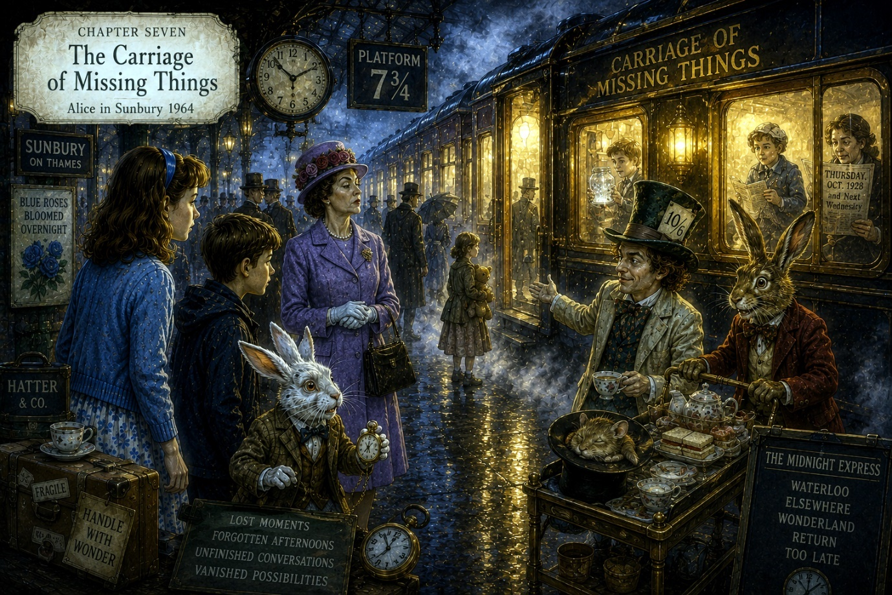

Chapter Seven

The Carriage of Missing Things
Rain hissed softly against the Midnight Express.
Steam curled through the station lamps like drifting ghosts.
And upon Platform 7¾, nobody moved.
Not even the clocks.
Mrs Redgrave stood calmly beside the train in her lavender coat, one gloved hand resting lightly upon her handbag as though she were waiting for a delayed appointment rather than the possible collapse of reality.
“You cannot seriously mean to send her aboard,” cried the White Rabbit.
“My dear Rabbit,” replied Mrs Redgrave smoothly, “the town is already unraveling.”
The Rabbit clutched his pocket watch desperately.
“The crossings can still be stabilised.”
“No,” she said quietly. “Not this time.”
Alice looked from one to the other.
“What exactly are the missing seven minutes?”
Nobody answered immediately.
At last, the Rabbit spoke.
“They are leftovers.”
“That explains absolutely nothing.”
“Time,” said the Rabbit carefully, “occasionally sheds things.”
Peter frowned.
“Time sheds things?”
“Oh yes,” said the Rabbit miserably. “Lost moments. Forgotten afternoons. Nearly remembered dreams. Unfinished conversations. Vanished possibilities.”
The train gave a low whistle.
Not loud.
Lonely.
Alice glanced toward its glowing windows.
Inside, shadowy passengers sat silently beneath brass lamps.
Some appeared ordinary.
Others decidedly did not.
A woman knitted clouds.
A small boy held a jar containing snowfall.
An elderly gentleman appeared to be asleep beneath a newspaper dated Thursday, October 1928 and Next Wednesday.
The Rabbit lowered his voice.
“The missing seven minutes collected aboard the train.”
“Why?”
“Because the Midnight Express gathers lost things.”
Mrs Redgrave stepped closer.
“And unless those minutes are returned,” she said calmly, “Sunbury will continue slipping.”
As if to prove her point, the station behind them suddenly flickered.
For one impossible second the platform transformed completely.
Alice glimpsed:
- gas lamps instead of electric lights
- Victorian travellers
- piles of trunks
- horse-drawn carriages outside the station
- a little girl in 1880s clothing chasing a paper boat across the platform
Then reality snapped back again.
Passengers gasped.
A station porter crossed himself hurriedly.
Peter went pale.
“I think the station just became old.”
“It does that now,” muttered the Rabbit.
The train doors remained open.
Waiting.
Inviting.
Alice stepped closer.
Warm golden light spilled from the nearest carriage onto the rain-dark platform.
Above the door, polished brass lettering read:
CARRIAGE OF MISSING THINGS
Mrs Redgrave watched her carefully.
“You see the problem now.”
Alice turned sharply.
“No,” she said. “I think I see your problem.”
Mrs Redgrave’s eyes narrowed slightly.
Alice gestured toward the impossible platform, the shifting clocks, the frightened passengers.
“You want to get rid of Wonderland because it’s untidy.”
“I want stability.”
“You want neatness.”
“I want reality.”
“But people need this place.”
Mrs Redgrave looked genuinely puzzled.
“Why?”
The question hung quietly in the damp air.
Even the Rabbit seemed startled by it.
Alice thought suddenly of:
- blue roses blooming overnight
- impossible lanes
- tea beside the silver Thames
- songs drifting through the rain
- forgotten moments waiting patiently aboard strange trains
And she realised something important.
Wonderland was not merely somewhere people visited.
It was where lost things went when the ordinary world stopped believing in them.
Mrs Redgrave spoke again.
“Imagination is all very charming in moderation. But it spreads. Soon people begin questioning things. Time becomes unreliable. Streets wander. Rivers refuse boundaries.”
“That sounds wonderful,” said Alice.
“It sounds expensive.”
The Hatter’s voice suddenly drifted from somewhere behind the steam.
“Everything important is expensive.”
Everyone turned.
The Mad Hatter emerged through the mist carrying a battered umbrella patterned with dancing teapots.
The March Hare followed pushing a trolley full of sandwiches and electrical wires.
The Dormouse slept peacefully inside a conductor’s hat.
“You’re late,” snapped the Rabbit.
“We stopped for cake,” replied the Hatter.
The Hatter approached Alice slowly.
Then his expression softened as he looked toward the glowing carriage.
“Ah,” he murmured. “The Missing Things carriage.”
“You know it?”
“I once misplaced an entire Thursday there.”
“That sounds inconvenient.”
“It was an excellent Thursday too.”
The train whistle sounded again.
Farther down Platform 7¾, the waiting passengers slowly began boarding.
The little girl with the teddy bear stepped aboard first.
Then the man from 1928.
Then others carrying strange forgotten fragments of their lives.
Alice looked into the glowing carriage once more.
And there, briefly reflected in the window glass behind her own reflection, she saw something impossible.
Not Wonderland.
Not Sunbury.
But herself as an old woman standing upon the same platform many years later, still searching for something she had once almost remembered.
The image vanished instantly.
Alice stepped backward, shaken.
The Hatter watched her carefully.
“Yes,” he said quietly. “The train does that sometimes.”
“What did I just see?”
“Possibilities.”
The station lights flickered violently.
Thunder rolled overhead.
And somewhere deep inside the Midnight Express, a clock began striking thirteen.

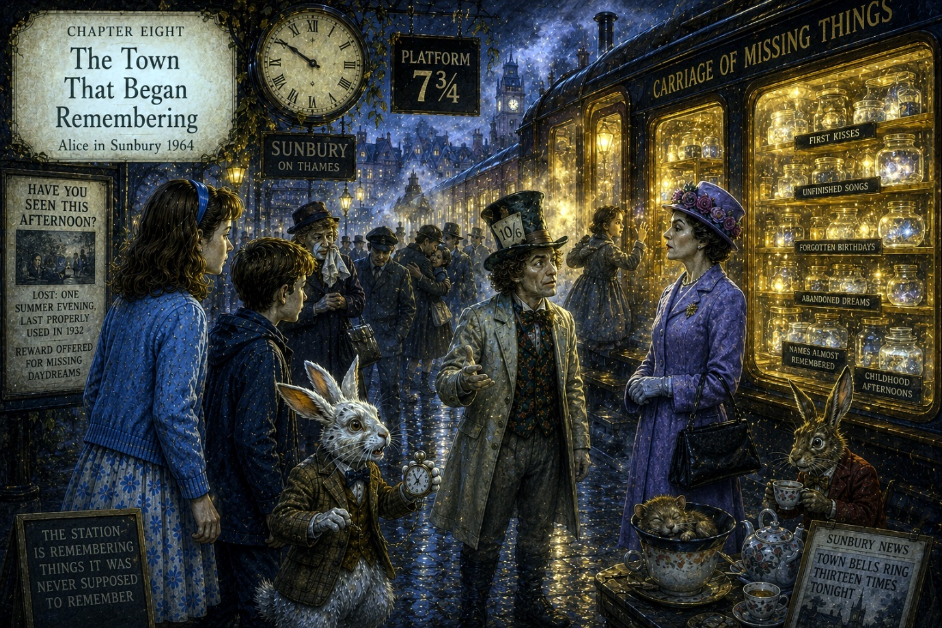

Chapter Eight

The Town That Began Remembering
The thirteenth chime echoed through the station like a crack spreading through glass.
Then everything went wrong at once.
Not violently.
Wonderland rarely behaved violently when confusion would suffice.
The station lamps flickered between decades.
Steam thickened into fog.
Passengers faded briefly transparent.
And beyond the rain-soaked windows of the station, the town of Sunbury-on-Thames began remembering things it was never supposed to remember.
The first sign came when the station advertisements changed.
Holiday posters vanished.
In their place appeared enormous painted notices reading:
HAVE YOU SEEN THIS AFTERNOON?
LOST: ONE SUMMER EVENING, LAST PROPERLY USED IN 1932
REWARD OFFERED FOR MISSING DAYDREAMS
A businessman stared at the posters in horror.
“I remember that afternoon,” he whispered suddenly.
Nobody listened.
Because everybody else was beginning to remember things too.
On Platform Two, a woman burst into tears after recalling the exact smell of her childhood garden.
A porter sat heavily upon a luggage trolley after suddenly remembering a song his mother used to sing before the war.
Two old men embraced wordlessly beside the ticket office.
And somewhere nearby, someone laughed with the unmistakable relief of finding something they had not realised was missing.
Mrs Redgrave looked appalled.
“This is precisely the problem.”
The Hatter adjusted his enormous hat.
“You say that remarkably often.”
The station shook gently.
Farther along Platform 7¾, the Midnight Express glowed brighter now, its windows shining gold through the steam.
And the Carriage of Missing Things had begun opening its doors wider.
Inside, Alice glimpsed endless corridors lined with shelves.
Not shelves of books.
Shelves of moments.
Tiny glowing fragments floated inside glass jars:
- first kisses
- forgotten birthdays
- unfinished songs
- dreams abandoned too early
- names almost remembered
- childhood afternoons smelling of rain and warm bread
Peter stared open-mouthed.
“How can all that fit inside one train?”
“It doesn’t,” said the Rabbit. “The train cheats.”
“That hardly seems fair.”
“Neither is algebra,” muttered the Rabbit darkly.
The Hatter stepped beside Alice.
“You’re beginning to understand now.”
Alice nodded slowly.
“Wonderland keeps lost things safe.”
“Exactly.”
“Then why does Mrs Redgrave want to stop it?”
The Hatter’s expression softened sadly.
“Because people fear what reminds them they once imagined more than this.”
He gestured toward the ordinary station beyond the mist:
- commuters
- newspapers
- timetables
- umbrellas
- tired faces beneath electric lights
“People become practical,” he said quietly. “Then eventually they mistake practicality for wisdom.”
Nearby, Mrs Redgrave overheard this and stiffened slightly.
“There is nothing wrong with order.”
“No,” agreed the Hatter pleasantly. “Only too much of it.”
The train whistle sounded again.
This time the noise carried something else within it.
A voice.
Faint.
Calling.
Alice froze.
She knew that voice.
Soft.
Gentle.
Familiar.
“Alice…”
The sound drifted from somewhere inside the train.
Alice stepped forward instinctively.
The Rabbit panicked immediately.
“No no no no no.”
“She heard it too,” whispered Peter.
“Of course she did,” groaned the Rabbit. “It always does this.”
“What does?”
The Rabbit pointed accusingly at the train.
“It finds the thing you miss most.”
Alice stared into the glowing carriage.
Again came the voice.
Closer this time.
“Alice…”
And suddenly she remembered something she had not thought about for years.
A summer afternoon beside the Thames when she was very small.
Someone holding her hand.
Laughter.
Paper boats floating upon brown-green water.
Then nothing.
The memory vanished again before she could grasp it properly.
Alice turned sharply toward the Rabbit.
“What was that?”
The Rabbit looked deeply uncomfortable.
“The train doesn’t merely collect missing things.”
“What else does it do?”
“It returns them.”
Mrs Redgrave stepped forward quickly.
“And that,” she said firmly, “is exactly why the crossings must close.”
The station lights burst suddenly brighter.
All the clocks froze.
And somewhere beyond the fog-covered platforms, the town bells of Sunbury began ringing thirteen times too.

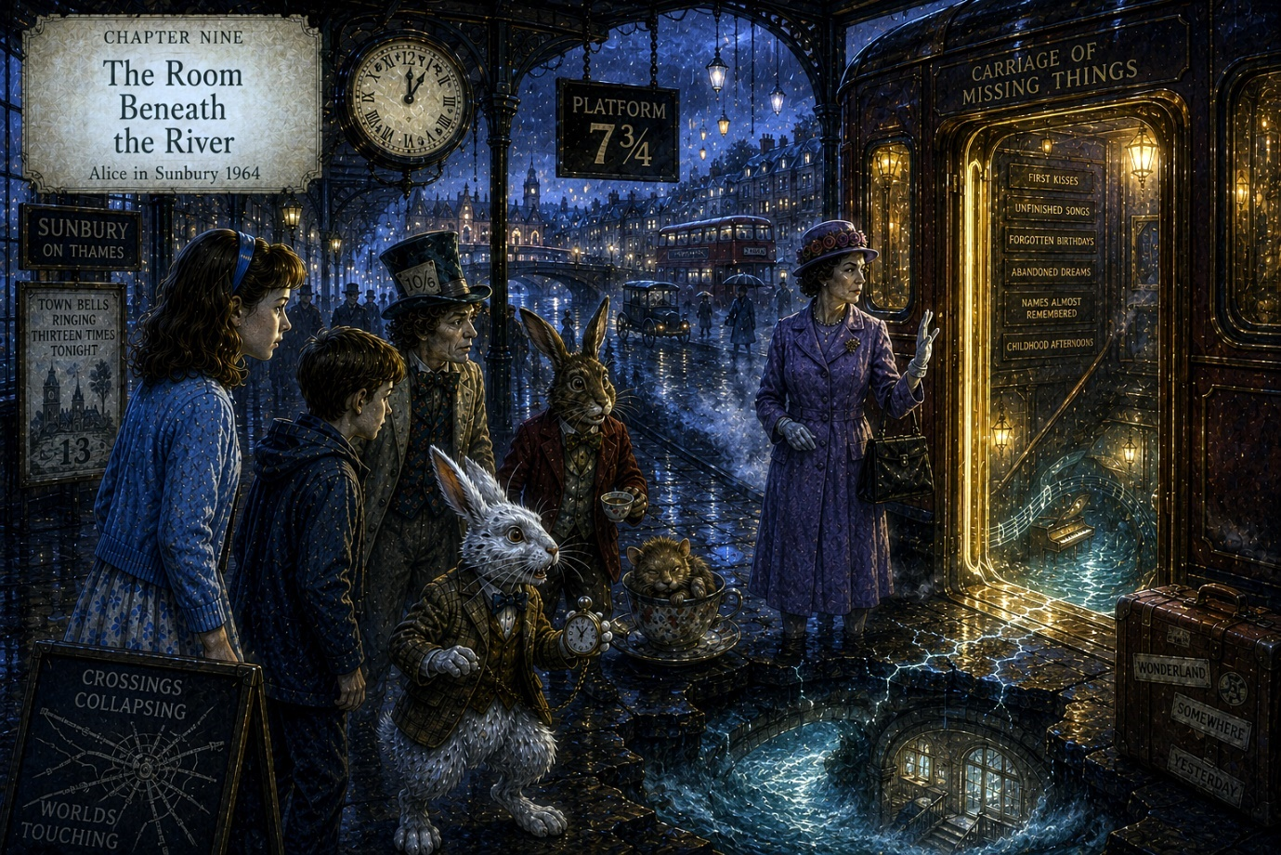

Chapter Nine

The Room Beneath the River
The bells of Sunbury-on-Thames continued striking thirteen.
Slowly.
Heavily.
As though the town itself had fallen out of step with the world.
The sound rolled across rooftops, through rain-soaked streets, along the Thames embankment, and deep into the glowing corridors of the Midnight Express.
Nobody upon the station platform spoke.
Even Mrs Redgrave appeared unsettled now.
“That should not be possible,” she murmured.
The Hatter smiled faintly.
“Oh, it’s possible. Wonderland adores impossible things.”
Another bell sounded.
The station flickered again.
This time the transformation lasted longer.
The tiled walls melted briefly into dark Victorian brickwork.
Electric lamps became gaslight.
Passengers shifted into strangers from other decades.
And through the station windows Alice glimpsed impossible things moving through the streets outside:
- a horse-drawn omnibus passing a modern bus
- children chasing floating paper lanterns
- a man in Edwardian clothing buying cigarettes from a 1960s vending machine
- reflections that moved several seconds before the people creating them
The Rabbit trembled violently.
“We’re running out of time.”
“That sentence feels inappropriate somehow,” said Peter.
The Rabbit ignored him.
“The crossings are collapsing into one another.”
Alice looked toward the glowing train carriage.
“What happens if they do?”
Nobody answered immediately.
At last, Mrs Redgrave spoke quietly.
“People forget which world they belong to.”
The station fell silent.
The answer frightened Alice far more than she expected.
Because already she understood what Mrs Redgrave meant.
Wonderland was not entirely separate from the ordinary world.
It existed beside it.
Beneath it.
Inside it.
And now the boundaries between the two were weakening.
The Midnight Express gave another soft whistle.
Then, somewhere inside the train, a door opened slowly by itself.
Warm golden light spilled across the platform.
The Rabbit’s ears drooped.
“Oh no.”
“What now?” asked Peter.
“The train has invited her.”
Alice frowned.
“Invited me where?”
The Hatter looked toward the open carriage door.
“To the room beneath the river.”
“That doesn’t sound remotely safe.”
“No,” agreed the Hatter. “It rarely is.”
Mrs Redgrave stepped sharply forward.
“She cannot go there.”
“She already belongs there,” replied the Hatter softly.
Alice stared at him.
“What does that mean?”
But before he could answer, the station floor trembled beneath their feet.
Far below the platforms came the deep rushing sound of water.
The Thames.
Except the river sounded far too close.
Cracks of silver light suddenly spread briefly across the station tiles before vanishing again.
Passengers gasped.
And from somewhere beyond the fog came the distant roar of a train moving where no tracks existed.
The Rabbit buried his face in his paws.
“It’s happening again.”
The Hatter turned to Alice.
“You must listen carefully now.”
For once his voice carried no madness at all.
Only urgency.
“Long ago, certain places were built where the worlds touched lightly together.”
“The lane behind the garages.”
“Yes.”
“The tea party.”
“Yes.”
“The station.”
The Hatter nodded.
“And beneath the Thames itself.”
Alice frowned.
“How can there be a room beneath a river?”
“Very carefully,” replied the Hatter.
The open carriage glowed brighter.
Inside, Alice could now see a narrow corridor descending downward impossibly far.
And drifting faintly upward from somewhere below came music.
Not gramophone music this time.
Piano music.
Slow.
Beautiful.
Terribly sad.
The melody tugged painfully at Alice’s memory.
“I know that tune,” she whispered.
The Rabbit looked at her with sudden pity.
“Of course you do.”
Mrs Redgrave stepped forward quickly.
“You must not encourage this.”
“Encourage what?” snapped Alice.
Mrs Redgrave hesitated.
Then, very quietly, she said:
“The river remembers you.”
A strange coldness passed through Alice.
“The river?”
“There was another crossing here once,” said Mrs Redgrave. “Years ago.”
The Hatter removed his hat solemnly.
The Rabbit looked away.
Even Peter suddenly seemed afraid to ask questions.
Alice stared from face to face.
“What happened?”
The station lights dimmed.
The rain outside softened.
And beneath the distant sound of bells and steam and shifting clocks came the slow endless murmur of the Thames flowing somewhere beneath everything.
At last the Hatter answered gently.
“You disappeared once before, Alice.”
The piano music below the river continued playing.
And the open carriage door waited patiently for her to enter.

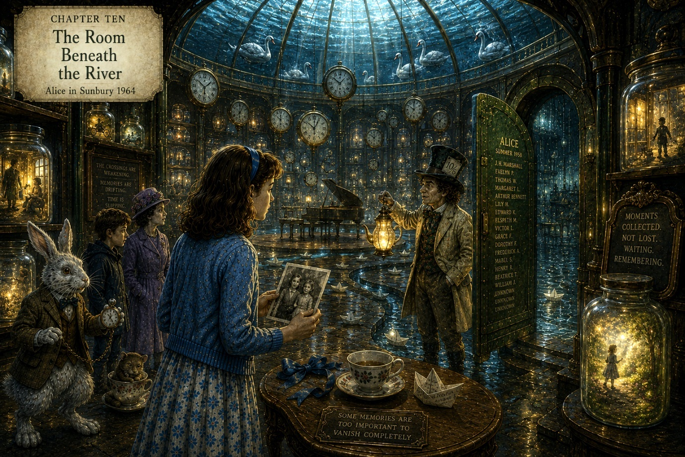

Chapter Ten

The Room Beneath the River
Alice stepped aboard the Midnight Express.
Immediately the sounds of the station softened behind her.
The rain.
The bells.
The frightened voices.
All faded gently away as the carriage door closed with a quiet click.
Warm golden light filled the corridor.
The air smelled faintly of:
- old books
- river water
- candle wax
- tea leaves
- summer evenings after rain
The corridor stretched impossibly far downward.
Not steeply.
Not sharply.
But gradually, as though the train itself were descending through memory rather than distance.
The walls glowed softly with polished wood and brass fittings.
And behind glass panels lining both sides of the corridor floated thousands upon thousands of lost things.
Not objects.
Moments.
Alice passed them slowly.
Inside one glowing panel:
a little boy learned to ride a bicycle beneath autumn trees.
Inside another:
an elderly woman danced alone in her kitchen while supper burned cheerfully behind her.
Farther on:
two sisters whispered secrets beneath blankets by torchlight.
The moments moved softly like living photographs.
None lasted more than a few seconds before fading gently into golden mist.
Alice stopped before another panel.
A man stood beside the Thames in 1931 tossing breadcrumbs to swans while a woman laughed beside him.
The scene shimmered.
Then vanished.
A brass plaque beneath the glass read:
A PERFECTLY ORDINARY TUESDAY THAT NOBODY REMEMBERED PROPERLY
Alice swallowed quietly.
“This place is enormous.”
“Of course it is.”
She turned.
The Hatter stood farther down the corridor holding a lantern shaped like an upside-down teapot.
“How did you get in here?”
“I know a side entrance.”
“That seems suspicious.”
“Wonderland generally is.”
The Hatter’s voice echoed softly through the endless glowing passage.
“You must understand something important, Alice.”
“What?”
“The world sheds far more than people realise.”
He gestured toward the glowing panels.
“Most moments disappear forever. But some are too important to vanish completely.”
Alice looked around again.
“And this place keeps them?”
“For a while.”
The corridor trembled gently.
Somewhere far above them came the muffled sound of train whistles and distant thunder.
“The crossings are weakening faster now,” said the Hatter quietly.
“Because of the missing seven minutes?”
“Partly.”
Alice frowned.
“Then what’s the other reason?”
The Hatter hesitated.
Then he sighed.
“You forgot.”
Alice stared at him.
“What did I forget?”
The Hatter lifted the lantern higher.
Its golden light flickered across the corridor walls.
And suddenly Alice realised the train was no longer moving.
Ahead stood a great circular door of dark green metal set into ancient brickwork wet with river water.
The sound of the Thames roared softly beyond it.
Not above them.
Around them.
The Hatter approached the door carefully.
Upon its surface were engraved hundreds of names.
Some faded almost invisible.
Some glowing brightly.
Alice recognised none of them.
Except one.
ALICE
Her breath caught.
Beneath her name appeared a date.
SUMMER 1958
The corridor suddenly felt very cold.
“That’s impossible,” whispered Alice.
“I’m afraid not.”
“I wasn’t here in 1958.”
“You were.”
The Hatter’s expression softened sadly.
“You simply don’t remember.”
Before Alice could speak again, the great green door slowly opened inward by itself.
River mist rolled outward.
And beyond the doorway lay the Room Beneath the River.
It was beautiful.
And heartbreaking.
A vast circular chamber stretched impossibly beneath the Thames itself.
Water flowed silently above the glass-domed ceiling where moonlight shimmered through drifting currents and shadows of passing swans.
Hundreds of clocks hung suspended in the air.
None agreed upon the time.
Pianos played quietly by themselves in distant corners.
Paper boats drifted through shallow streams crossing the marble floor.
And everywhere stood shelves upon shelves of forgotten memories preserved inside glowing jars.
Some glowed warmly.
Others flickered weakly as though close to vanishing forever.
Alice walked slowly into the chamber.
Then she froze.
At the very centre of the room stood a small wooden table beside the water.
Upon it sat:
- a blue ribbon
- a child’s teacup
- a paper boat
- and a photograph
Alice picked up the photograph with trembling fingers.
It showed herself.
Not as she was now.
Smaller.
Perhaps six years old.
Standing beside the river in Sunbury during summer sunshine.
And holding her hand was another little girl.
A girl Alice recognised instantly despite not remembering her at all.
The photograph shook slightly in her grasp.
“Who is she?” whispered Alice.
The Hatter removed his hat quietly.
For once there was no trace of foolishness in him at all.
“That,” he said gently, “is your sister.”

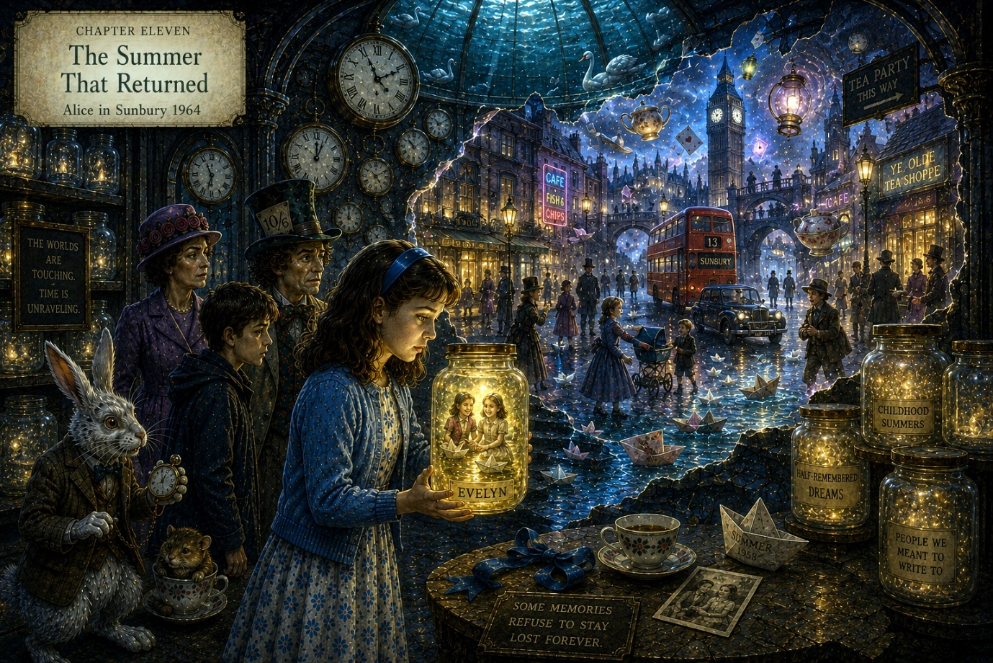

Chapter Eleven

The Summer That Returned
The photograph trembled in Alice’s hands.
The little girl beside her smiled brightly at the camera, one shoe untied, hair blown untidily by the riverside wind.
She looked familiar in the painful way forgotten things sometimes do.
Not remembered fully.
Only felt.
Alice stared at the image.
“My sister?”
The Hatter nodded quietly.
“You came here together once.”
“But I don’t have a sister.”
“You did.”
The words echoed through the Room Beneath the River like a stone dropped into deep water.
Around them, clocks ticked unevenly.
Paper boats drifted silently through the marble channels.
And somewhere above the glass ceiling, the Thames rolled darkly through the night above Sunbury-on-Thames.
Alice looked up sharply.
“What happened to her?”
The Hatter hesitated.
Then, softly:
“She was forgotten.”
The room itself seemed to shiver.
Mrs Redgrave closed her eyes briefly.
Even the White Rabbit removed his spectacles sadly.
“That’s impossible,” whispered Alice.
“No,” said Mrs Redgrave quietly. “Only terrible.”
The piano somewhere in the chamber continued playing the same haunting melody.
Alice realised suddenly why it sounded familiar.
It was a lullaby.
A lullaby somebody once sang beside the river long ago.
She almost remembered the words.
Almost.
The Hatter guided Alice slowly toward one of the glowing shelves.
Upon it rested hundreds of glass jars filled with pale drifting light.
Each carried labels:
- HALF-REMEMBERED DREAMS
- PEOPLE WE MEANT TO WRITE TO
- CHILDHOOD SUMMERS THAT ENDED TOO QUICKLY
- THINGS LOST DURING MOVING HOUSE
And near the centre stood one small jar glowing brighter than the others.
Its label simply read:
EVELYN
Alice stopped breathing.
The name struck her like lightning.
Not unfamiliar.
Hidden.
Buried.
She reached toward the jar slowly.
Inside swirled sunlight upon river water.
Two girls laughing.
Paper boats.
Blue ribbons.
A voice calling her name.
Alice touched the glass.
And suddenly the memory returned.
Summer 1958.
A riverside picnic beside the Thames.
A narrow lane hidden behind hedges.
A tea party beneath willow trees.
And another little girl holding her hand tightly.
Evelyn.
Her sister.
The memory hit Alice so hard she staggered backward.
“I remember her.”
The Rabbit’s eyes filled with relief.
“Oh thank goodness.”
Alice pressed trembling fingers against her forehead.
“She fell.”
Nobody spoke.
The room grew utterly still.
“She fell into the river.”
The Hatter lowered his head.
“It was during a crossing,” he said gently.
“The worlds were shifting.”
Alice remembered now:
- thunder over the Thames
- clocks striking wrongly
- lanterns swinging beneath willow trees
- strange pathways opening beside the river
And Evelyn slipping from her grasp.
Alice’s breath caught painfully.
“I couldn’t find her.”
“You tried,” whispered the Rabbit.
“For days.”
Mrs Redgrave spoke quietly behind them.
“The river kept part of her.”
Alice turned sharply.
“What does that mean?”
Mrs Redgrave approached the glowing jar carefully.
“Crossings are dangerous because the worlds do not always separate cleanly. Some people become... misplaced.”
The word sounded unbearably cold.
“She isn’t dead,” said Alice.
Nobody answered.
Instead, the entire chamber trembled violently.
Far above them came the roaring sound of bells, steam whistles, and rushing water.
The Hatter looked upward sharply.
“The town’s slipping faster.”
The walls of the chamber flickered.
For one impossible instant, the Room Beneath the River vanished entirely.
In its place Alice saw Sunbury transformed:
- gas lamps beside neon signs
- Victorian children playing beside 1960s buses
- floating teacups drifting above rooftops
- the Thames glowing silver beneath two different moons
- streets folding into impossible directions
Wonderland was no longer hidden.
It was breaking through everywhere.
The chamber snapped back into place.
Several clocks shattered.
Paper boats spun wildly through the channels.
The Rabbit panicked.
“We’re out of time.”
“That sentence again,” muttered Peter weakly.
The Hatter turned urgently toward Alice.
“The crossings are opening because you remembered.”
Alice stared at him.
“What?”
“Wonderland was never trying to escape into Sunbury.”
The Hatter’s eyes shone sadly beneath the lantern light.
“It was trying to return someone home.”
The glowing jar marked EVELYN brightened suddenly.
And from somewhere beyond the chamber walls came the unmistakable sound of a little girl laughing beside the river.

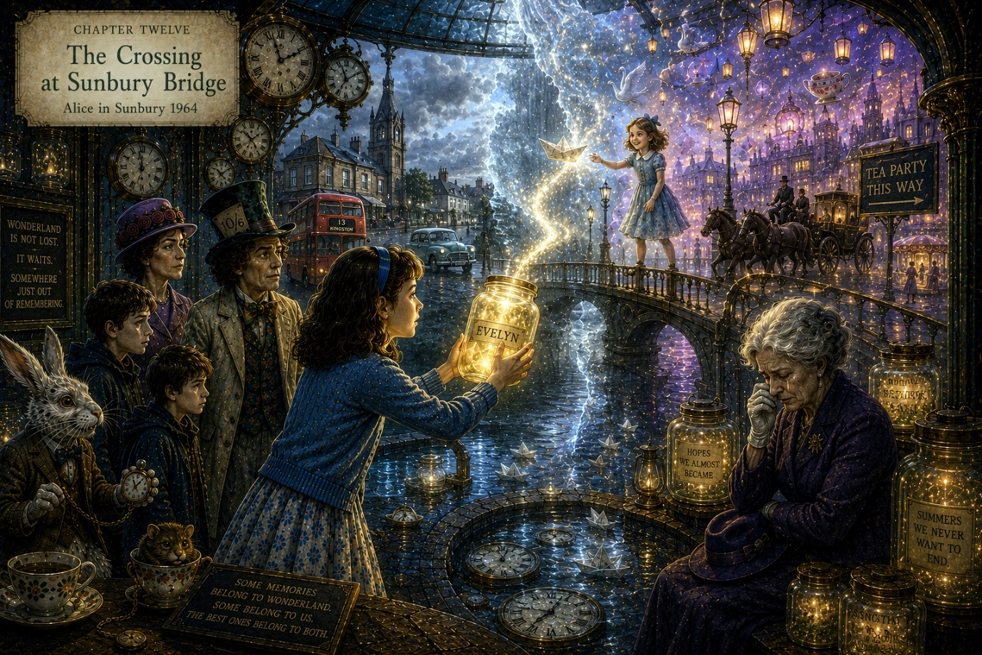

Chapter Twelve

The Crossing at Sunbury Bridge
The laughter echoed again.
Not loudly.
Not ghostly.
Simply familiar.
A child laughing beside the river on a warm summer afternoon.
Alice clutched the glowing jar marked EVELYN tightly against her chest.
And all around the Room Beneath the River, the world continued coming apart.
Clocks struck impossible hours.
Water ran briefly upward through the marble channels.
The glass ceiling above them shimmered as though the Thames itself were becoming uncertain.
The Hatter looked upward sharply.
“We haven’t much time.”
“There it is again,” muttered Peter. “Everyone suddenly obsessed with time.”
“Naturally,” snapped the Rabbit. “Time is escaping.”
The chamber trembled violently.
Then somewhere above them came a terrible sound.
The cracking of glass.
Mrs Redgrave turned pale.
“The crossing has opened completely.”
The walls of the chamber dissolved suddenly into silver mist.
And beyond them, Alice saw all of Sunbury-on-Thames transformed.
Wonderland and the ordinary world had collided entirely.
Sunbury Bridge stretched impossibly across two rivers at once.
One flowed brown-green beneath rainy English skies.
The other shimmered silver beneath drifting lanterns and impossible stars.
Buses rolled beside horse-drawn carriages.
Gas lamps glowed beside neon signs.
The church bells rang thirteen while floating teacups drifted above rooftops like curious birds.
And everywhere people stood perfectly still, remembering things.
Not only lost memories.
Lost selves.
Who they once hoped to become.
Who they almost were.
Mrs Redgrave stared at the collapsing vision in horror.
“This is exactly what I feared.”
Alice turned on her.
“No,” she said quietly. “This is what you tried to stop.”
Mrs Redgrave looked suddenly very tired.
“You don’t understand.”
“Then explain it.”
The older woman stood silently for a long moment while the strange silver light flickered around them.
At last she whispered:
“I remembered too much once.”
The chamber grew quiet.
Even the clocks seemed to pause.
Mrs Redgrave removed one white glove slowly.
Beneath it, Alice saw faded blue ink upon her wrist.
A child’s handwriting.
DON’T FORGET ME
Alice stared.
Mrs Redgrave’s voice trembled slightly now.
“My brother disappeared during a crossing in 1926.”
The Rabbit closed his eyes sadly.
“Oh.”
“I searched for years,” she continued softly. “Every crossing. Every tea room. Every impossible lane.”
Her expression hardened again.
“But Wonderland never returns things cleanly.”
The Hatter lowered his gaze.
“No,” he admitted.
Mrs Redgrave looked toward the silver river above them.
“People who remain too long between worlds forget how to live in either of them.”
Alice finally understood.
Mrs Redgrave had not been fighting Wonderland because she hated wonder.
She had been fighting grief.
The chamber shook again.
A great crack split the glass ceiling overhead.
Silver water began pouring slowly downward through the fracture, hanging impossibly suspended in the air like drifting ribbons.
And through the falling water, Alice suddenly saw her.
A little girl standing upon Sunbury Bridge beneath lantern light.
Blue ribbon in her hair.
Paper boat in her hands.
Evelyn.
Alice gasped.
The little girl looked exactly as she had in the photograph.
Neither older nor younger.
Simply waiting.
“Alice,” whispered the Hatter urgently. “The crossing is choosing.”
“What does that mean?”
“You can stabilise the worlds.”
“How?”
The Rabbit pointed toward the glowing jar.
“She was lost because the crossing remained unfinished.”
Alice looked from the jar to the bridge above.
Understanding came slowly.
Painfully.
“The crossing stayed open because I never let her go.”
The Hatter said nothing.
He did not need to.
Alice stepped toward the silver water falling through the shattered ceiling.
“Alice,” whispered Peter fearfully.
She smiled sadly at him.
“It’s all right.”
Then she lifted the glowing jar gently toward the drifting image of Evelyn.
The light inside the glass brightened warmly.
The little girl upon the bridge smiled.
And suddenly Alice remembered the final thing.
Not falling.
Not fear.
Not loss.
But Evelyn laughing beside the river moments earlier while launching paper boats into the Thames.
Happy.
Entirely happy.
The memory settled quietly into place at last.
Alice opened the jar.
Golden light poured upward into the silver water.
The bridge above them blazed with impossible radiance.
The clocks stopped.
The bells ceased.
And for one perfect moment, all the worlds aligned peacefully together.
Evelyn looked at Alice one final time.
Then she stepped backward into the lantern light and vanished softly like the end of a summer evening.
The crossing closed.
Silence followed.
Gentle.
Warm.
Final.
Slowly, the Room Beneath the River steadied.
The silver Thames above returned to ordinary moonlit water.
The clocks resumed sensible ticking.
And somewhere far away in the ordinary streets of Sunbury, a bus conductor cheerfully announced the late evening service to Kingston.
Mrs Redgrave sat down heavily beside the water channels, tears silently running down her face.
The Hatter placed his enormous hat gently upon her head.
“Sometimes,” he said quietly, “remembering hurts.”
The Rabbit sniffed loudly.
Peter pretended not to notice.
Alice stood beneath the glass dome watching the river flow overhead.
Wonderland had not vanished.
She knew now it never truly would.
It would remain:
- in forgotten lanes
- in impossible tea parties
- in railway stations after rain
- in old songs
- in summer evenings beside rivers
- and in every ordinary place where the world briefly remembered how strange and beautiful it really was.
And somewhere beyond the drifting reflections of the Thames, Alice could almost hear paper boats touching softly against the shore.

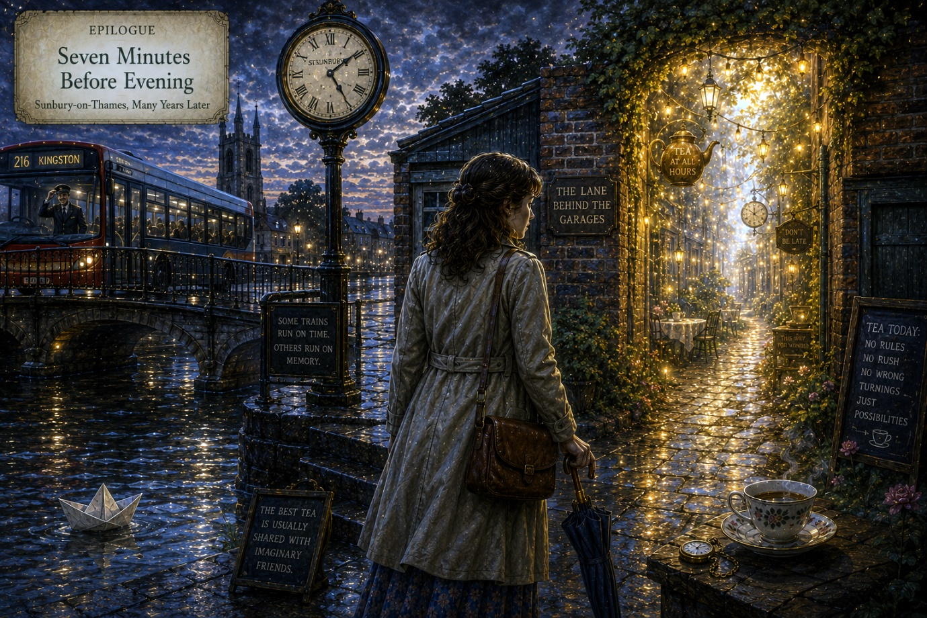

Epilogue

Seven Minutes Before Evening
Many years later, Alice returned to Sunbury-on-Thames on a rainy Thursday in October.
The town had changed.
Of course it had.
The old station café was gone.
Several streets seemed narrower than she remembered.
New buildings stood where old gardens once grew.
The buses were different now.
No conductors.
No silver ticket machines clicking cheerfully in warm summer air.
And yet certain things remained stubbornly familiar:
- the smell of rain upon pavements
- the river moving quietly beneath the bridge
- distant church bells through evening mist
- lamps glowing amber beside wet roads
Alice walked slowly through the town carrying a small brown suitcase and a folded umbrella.
She had not visited Sunbury in decades.
Not properly.
Life, as it tends to do, had become filled with practical things:
- work
- moving house
- letters unanswered
- birthdays accidentally forgotten
- ordinary years passing quietly one after another
And yet every now and then, usually during rainy evenings or while hearing distant train whistles, she would remember impossible things.
A silver river.
A tea party beneath willow trees.
Paper boats.
The sound of clocks striking thirteen.
People told themselves many things as they grew older.
But Alice had long ago decided that denying wonder required far more effort than accepting it.
The rain softened.
She crossed Sunbury Bridge slowly.
The Thames rolled dark beneath the lamps.
And there, caught briefly against the riverside steps below, floated a small paper boat.
Alice stopped walking.
The boat drifted gently in circles against the current.
Impossible.
Paper should have sunk long ago in weather like this.
Very slowly, Alice smiled.
“Well,” she murmured softly. “Good evening to you too.”
A bus passed behind her with a hiss of wet tyres.
She turned absently toward it.
And froze.
For just a moment, illuminated by rainy lamplight through the misted windows, she saw a small man in an old-fashioned conductor’s uniform tip his hat politely toward her.
Then the bus moved on.
Ordinary again.
Alice stood perfectly still upon the bridge.
Farther along the embankment came faint music.
Gramophone music.
Warm and crackling.
Almost lost beneath the rain.
Without quite deciding to, Alice followed it.
The riverside path curved through damp autumn trees glowing gold beneath the lamps.
And then she saw it.
Between two old brick garages stood a narrow lane.
A lane that absolutely did not belong there.
Soft golden light spilled gently from within.
The scent of tea leaves and river water drifted toward her.
And somewhere far along its winding hidden distance came laughter.
Not loud.
Not haunting.
Simply familiar.
Alice stood at the entrance a very long time.
The lane waited patiently.
As though it had always known she would return eventually.
Then, from somewhere deep within the golden mist, a voice drifted softly outward:
“Honestly, Rabbit, she’s late again.”
Another voice replied at once:
“She always was.”
Alice laughed quietly despite herself.
The years seemed suddenly very thin.
Like old paper held before lantern light.
She looked once more toward the ordinary streets of Sunbury behind her:
- traffic lights glowing red in the rain
- shop windows reflecting evening traffic
- people hurrying home beneath umbrellas
- the practical world carrying on exactly as it always had
Then she looked back toward the impossible lane.
At the warm golden light.
At the drifting music.
At the place where wonder waited quietly beside ordinary life.
And smiling softly to herself, Alice stepped forward into the lane as the evening closed gently behind her.

www.thecrazymadwriter.com

